11/9/2021

|  |
| --- |
| Lab Report: 01  Hasan Uddin |

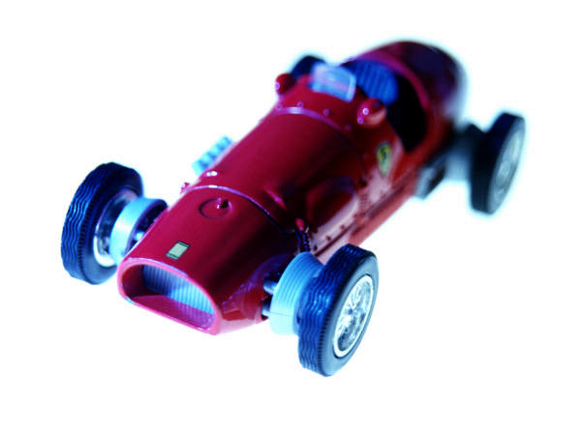

|  |  |
| --- | --- |
|  | simulation laboratory |



**UNITED INTERNATIONAL UNIVERSITY**

**Lab Report: 01**

**Course Title – Simulation Laboratory**

**COURSE CODE- EEE 2000**

**Fall 2021**

|  |  |  |  |  |  |  |  |  |
| --- | --- | --- | --- | --- | --- | --- | --- | --- |
| **0** | **2** | **1** | **2** | **0** | **3** | **0** | **1** | **1** |

**ID:**

|  |
| --- |
| **Hasan Uddin** |

**Name:**

|  |
| --- |
| **A** |

**Section:**

|  |
| --- |
| **01** |

**Experiment No:**

**Experiment Name**

|  |
| --- |
| **Code running on Mat lab** |

**Date of submission: 09/11/2021**

**Hasan Uddin**

**Signature of the student**

**Objective**

**We were introduced to MATLAB in our first Simulation Lab. In the lab, we learned about MATLAB settings, besides we learned to use some simple MATLAB commands from the commands window. We practiced some easy numerical and functional mathematical problems by using MATLAB. We learned about some shortcut tips and techniques also.**

**Contents of the Class**

**1. Some simple mathematical operations:**

>>4 + 9

ans = 13

>>10 – 5

ans = 5

>>3*4

ans = 12

>>5/2

ans = 2.5

>>2^3

ans = 8

**2. Variable Assigning:**

>>x = 3;

>>y=2;

>>z= (x+y)

ans = 5

**3. Functional Operation:**

>>x= sin (30)

x= -0.9880 ------{radian}

>>30*pi/180

=0.5 ------------ {degree}

>>asin (0.5*pi/180)

ans = 0.5235-------- {inverse value}

**4. Complex number operation:**

>>q = 3 + 4i

q = 3.00 + 4.00i

>>real (q)

ans= 3

>>image(q)

ans = 4

>>abs (q)

ans= 5 {magnitude of q}

>>angle (q)

ans = 0.9273 {Computes the phase of q (in radian)}

>>angle(q*pi/180)

ans= 53.1301 {Computes the phase of q (in degree)}

**Home Work (01)**

An object with an initial temperature of T0 that is placed at time t = 0 inside a chamber that has a constant temperature of T3 will experience a temperature change according to the equation.

T=T3 + (T0-T3)

**Where T is the temperature of the object at time t, and k is a constant. A soda can at a temperature of 120° F (after being left in the car) is placed inside a refrigerator where the temperature is 38°F. Determine, to the nearest degree, the temperature of the can after three hours. Assume k = 0.45. First define all of the variables and then calculate the temperature using one MATLAB command.**

**Code:**

>>T0 = 120;

>>T3 = 38;

>>t = 3;

>>k = 0.45;

>>T = T3 + ( T0 – T3 ) * exp (-k * t)

T=

59.2577

**Home work (02)**

**The arc length of a segment of a parabola ABC of an ellipse with semi-minor axes a and b is given approximately as,**

LABC = + ln ($\frac{4a+\sqrt{b^{2}+16a^{2}}}{b}$)

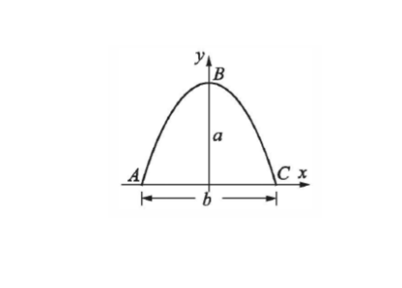Determine LABC if a=11 cm and b=9 cm.

aAA

**Answer to the following question**

Code:

>>a=11;

>>b=9;

>>LABC=0.5*(sqrt(b^2+(16*(a^2))))+((b^2/(8*a))*(log((4*a+(sqrt(b^2+(16*(a^2)))))/b)))

Answer = 24.5637